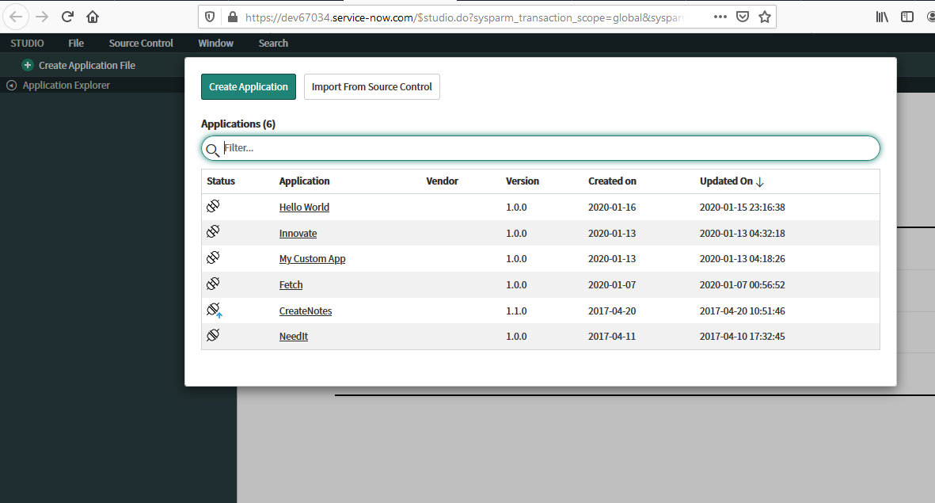**There are three main components in Snow Widget development.**

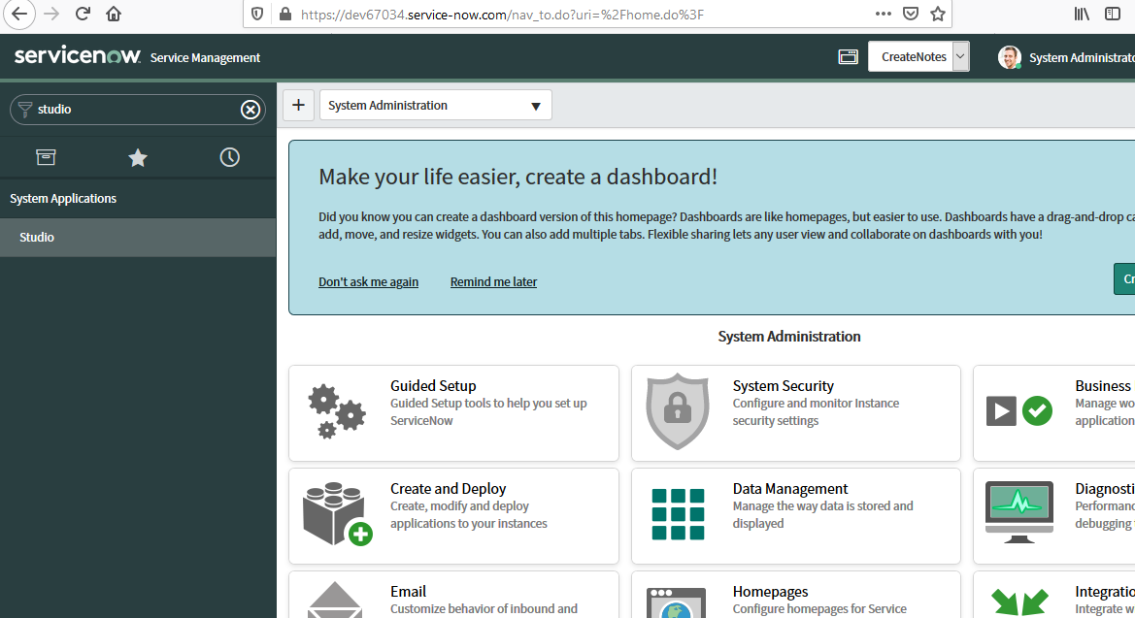

**Application Explorer**

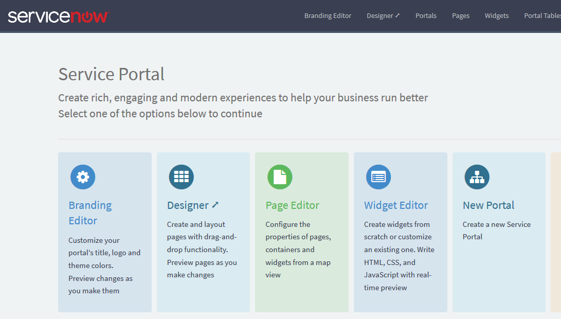

**Service Portal**

**Application Studio**

**Tutorial at :** [**https://developer.servicenow.com/app.do#!/lp/servicenow_application_developer/app_store_learnv2_serviceportal_newyork_exercise_explore_the_createnotes_application?v=newyork**](https://developer.servicenow.com/app.do#!/lp/servicenow_application_developer/app_store_learnv2_serviceportal_newyork_exercise_explore_the_createnotes_application?v=newyork)